**INDUSTRIAL QUANTUM ROBOT**

**WEEK - 8**

**KAVIN KISHORE S G** **7376221CS191**

1. Creating a 3D cube in OpenGL.

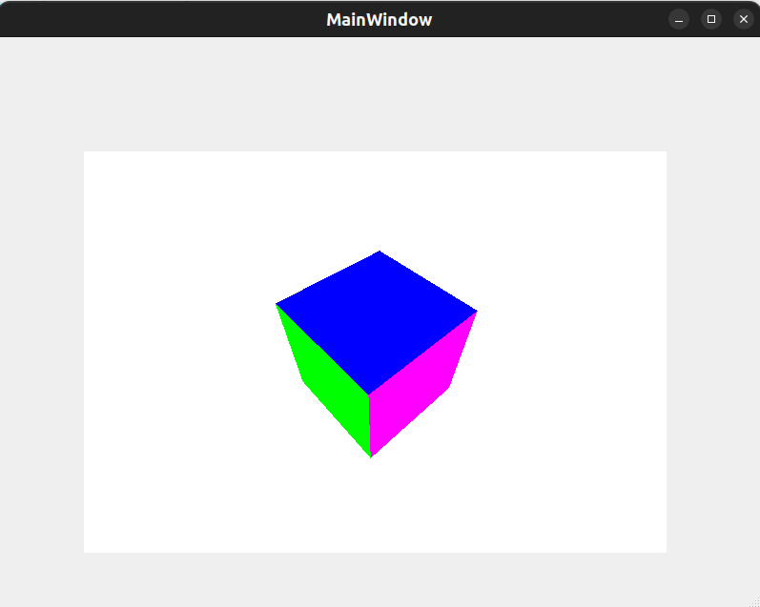

1. Creating a wall in OpenGL.

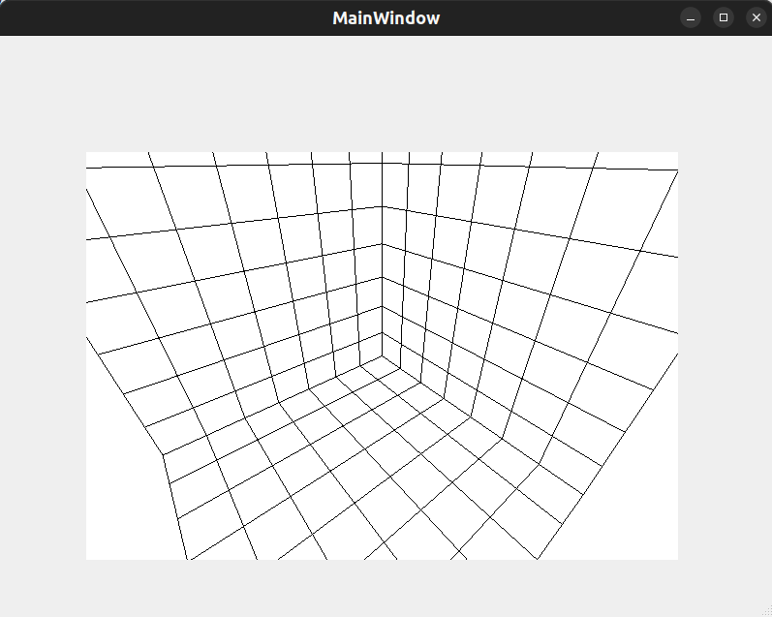

1. Creating a Square in OpenGL Wall.

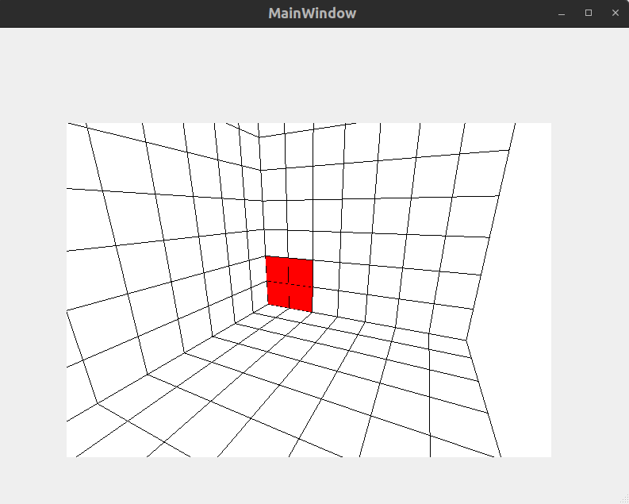

1. Creating a Rectangle in OpenGL Wall.

